REVISION OF GARDE 3 – SCHOOL YEAR 2019-2020

Content: Students learn by heart all the words from Unit 1 to Unit 6, Unit 7.
Grammar: Students review the following structures:
a. What time is it? It is twelve o’clock.
b. What do you like? I like balloons.
c. What does Sean like? He likes toys.
d. What do we have on Monday? We have English.
e. Do you have a milkshake? Yes, I do / No, I don’t.
Does Vicky have noodles? Yes, she does / No, she doesn’t.
f. How many boards are there? There are fifteen boards.
g. This is a new computer / That is an old egg.
These are tall trees / Those are small chairs.

READING AND WRITING:

I. Read and choose the correct words, then write them on the lines:

coins spoon winter a camel a forest shells clowns

1.This animal lives in desert. It helps people to carry heavy things. _______

2. You often see them when you go to the circus. _______

3.You can find a lot of trees and animals here. _______

4. It’s very cold in this season. You have to wear a coat. _______

5. You like collecting these things at the beach. They’re colorful. _______

6. You have to buy these when you play games at the mall. _______

II. Read the box and choose the correct verb:
goes catches a bus cooks likes get brushes

surf brush write collect

1. Sam _______ taking photos a lot. He often _________ to the zoo to take photos of the animals.

2. Vicky ________ her teeth every morning. Then, she _______ a bus to school.

3. Mom and Dad ________ up early in the morning. My mom _______ breakfast for my family.

III. Read the text and circle the best answer:

1.John: Which sports do you like playing ?

Jack: A. waterskiing, maybe
B. Not at all
C. I’m sure

2. Tom: Can I go fishing, dad?

Dad: A. Every afternoon, Tom.
B. Last time, Tom.
C. Sure, Tom.

3. Jane: When do you have breakfast?
Jill : A . I have it at 9 a.m
B. It isn’t late.
C. I has it at 9 a.m

IV. Unscramble the words:

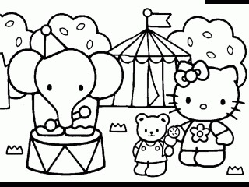
1.
o z o

i r a o p r t

p o r t
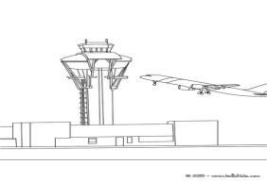
2.


3.

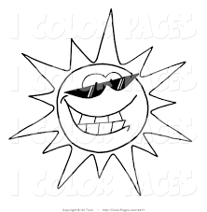
4.

__ __ __

__ __ __ __ __ __

n a k b

__ __ __ _

u n n y s

__ __ __ __ __

V. Answer the questions:

1. What do you like ? .........................................

2. What time is it?
........................................

__ __ __ __ __

ANSWER KEYS:

I. Read and choose the correct words, then write them on the lines:
1. a camel 2. clowns 3. a forest 4. winter 5. shells 6. Coins
II. Read the box and choose the correct verb:
1. likes – goes 2. brushes – catches 3. get – cooks
III. Read the text and circle the best answer:
1A 2C 3A
IV. Unscramble the words:
1.zoo 2.airport 3.plane 4. sunny
V. Answer the questions:
1. I like balloons/ cakes / apples ....
2. It is one o’clock / It is two o’clock....

